# Step 1: Create your zone

Go to <https://coursemgr.uqcloud.net/infs7901> and click create zone.

This will take up to 15 minutes

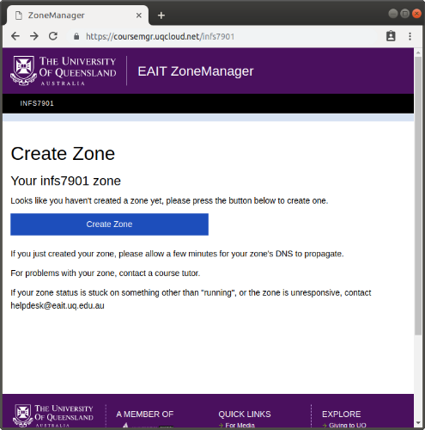

**Wait until it says your zone is running before clicking on the address.**

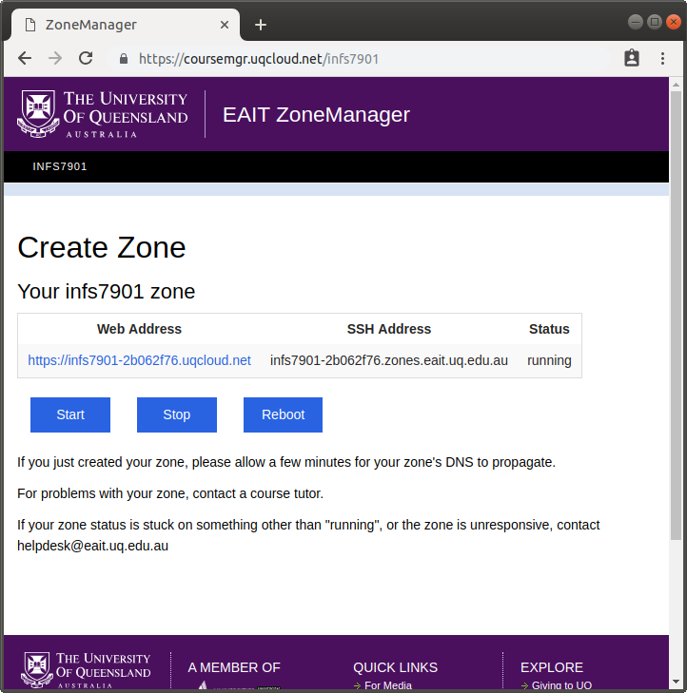

Your “zone name” is the part of the url after infs7901-.

In the above image the zone name is 2b062f76

# Navigate to phpmyadmin

Go to <https://infs7901-ZONENAME.uqcloud.net/phpmyadmin>

# Make a new database

On the left hand side click “new”

Give your database a name eg “INFS7901”

Click “create”  
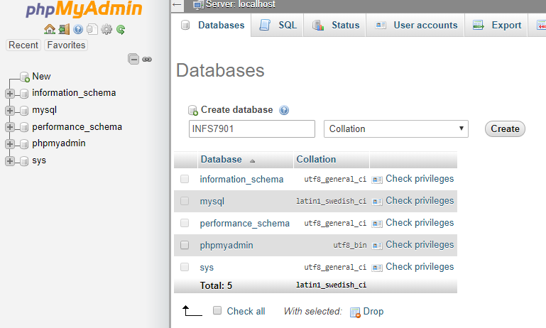

# Import files

Download “examples.sql” from Learning Resources on Blackboard

Click “Import” in phpmyadmin

Upload the file

Click Go

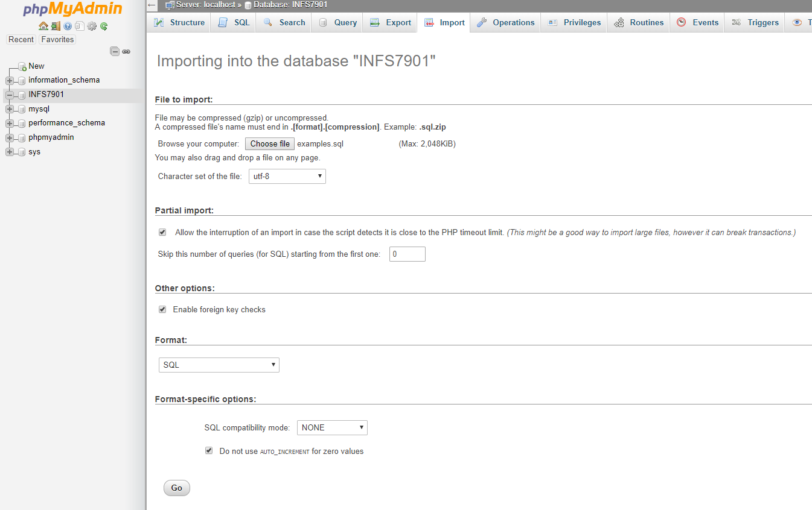

You are now ready to follow along in lectures!